# CHAPTER 05 :-

**Note:-** Always migrate other project folders directly to “Content” folder of your current project ; not any another folder or even sub-directory.

* **To Show Some Message in Output Log :-**

UE_LOG(LogTemp, Warning, TEXT("Begin Play Called!")) ;

* **To Show Debug Message of Actor On Screen :-**

if (GEngine) // If it is 0 means nullptr and will not run so check pointer 1st.

{

GEngine -> AddOnScreenDebugMessage(1, 60.0f, FColor::Cyan, FString("Testing Item On Screen!"));

}

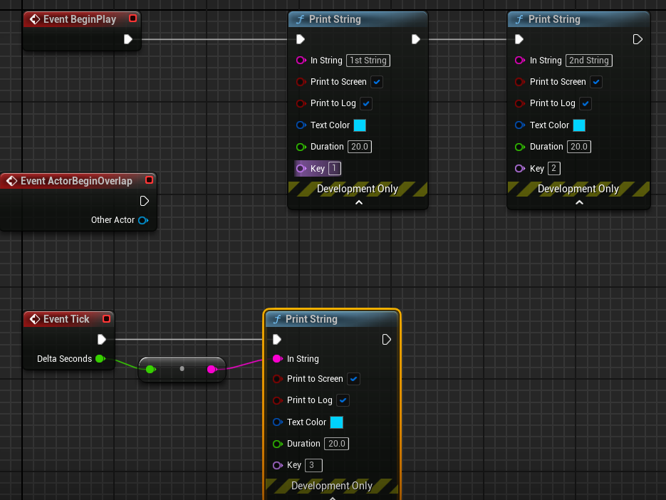

* **To Debug some format thing like frame seconds OR Actor_Name :-**

FString Name = GetName() ;

FString Message = FString :: Printf(TEXT("Item Name = %s") , *Name ) ;

FString Message = FString :: Printf(TEXT("DeltaTime = %f") , DeltaTime ) ;

GEngine -> AddOnScreenDebugMessage(1, 60.0f, FColor::Cyan, Message);

UE_LOG(LogTemp, Warning, TEXT("Item Name : %s"), *Name); // OR By Using Log also.

* **To Draw A Debug Sphere Over Actor while gameplay :-**

🡪 Important to include this header file #include<DrawDebugHelpers.h>

UWorld* World = GetWorld() ;

if ( World )

{

FVector Location = GetActorLocation() ;

DrawDebugSphere( World , Location , 25.0f , 24 , FColor :: Blue , false , 30.f ) ;

}

// OR by using Macro

#define MY_DEBUG_SPHERE( Location ) { if( GetWorld( ) ) DrawDebugSphere( GetWorld( ) , Location , 25.0f , 12 , FColor :: Red , true ) ; } // If true so debug sphere will never go away

* **To Draw A Debug Line Along Actor :-**

UWorld* World = GetWorld();

FVector Location = GetActorLocation();

FVector Forward = GetActorForwardVector() ; // It gets the forward (x-axis as we need to line to scale horizontally) unit vector (which means of 1 unit of UE i.e. 1cm ).

if( World )

{

DrawDebugLine(World, Location, Location + 100.0f * Forward, FColor :: Red, true , -1.0f , 0 , 1.0f ) ;

}

// OR

#define DRAW_LINE( Start_Location , End_Location ) { if( GetWorld( ) ) DrawDebugLine( GetWorld( ) , Start_Location , End_Location , FColor :: Red , true , -1.0f , 0 , 1.0f ) ; }

🡪 Macro_Call DRAW_LINE(Location, Location + Forward * 100.0f )

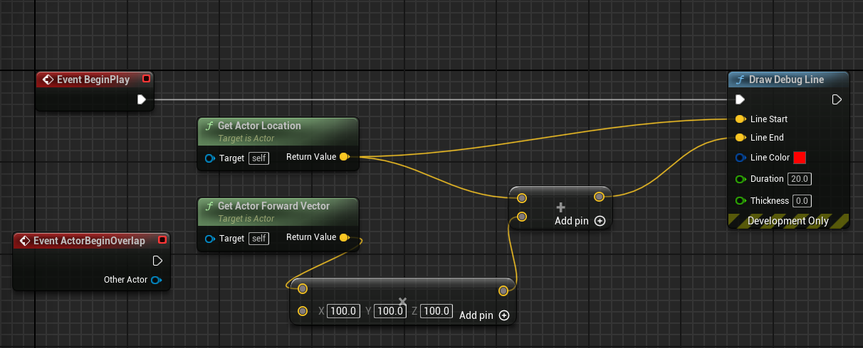

In Unreal Engine 5 (UE5), the “**Super”** keyword is used to call the implementation of a function in the parent class (or superclass). When you override a function in a subclass, you might still want to execute the functionality defined in the parent class before or after your subclass's code. This is where **Super** comes into play.

* **To Draw A Debug Point :-**

UWorld* World = GetWorld();

if (World)

{

DrawDebugPoint(World, Location + Forward * 100.0f, 15.0f, FColor :: Red, true);

}

// OR

#define DRAW_POINT( Location ) { if( GetWorld( ) ) DrawDebugPoint( GetWorld() , Location , 15.0f, FColor :: Red, true ); }

DRAW_POINT( Location + Forward * 100.0f )

* **To Draw Both Debug Point and Line at the Same Place :-**

// BackSlash allows macro definition to be entered in new line also.

#define DRAW_VECTOR( Start_Location , End_Location ) if ( GetWorld( ) ) \

{ DrawDebugLine(GetWorld(), Start_Location, End_Location, FColor :: Red, true, -1.0f, 0, 1.0f); \

DrawDebugPoint(GetWorld(), End_Location, 15.0f, FColor :: Red, true); \

}

🡪 Macro_Call DRAW_VECTOR(Location, Location + Forward * 100.0f)

* **OTHERS :-**

DrawDebugCircle(GetWorld(), CircleMatrix, 200, 50, FColor(0,104,167), true, -1, 0, 10);

DrawDebugCircle(GetWorld(), LocationFour, 200, 50, FColor(0,0,0), true, -1, 0, 10);

DrawDebugSolidBox(GetWorld(), MyBox, FColor(20, 100, 240), MyTransform, true);

DrawDebugBox(GetWorld(), LocationFive, FVector(100,100,100), FColor::Purple, true, -1, 0, 10);

DrawDebugLine(GetWorld(), LocationTwo, LocationThree, FColor::Emerald, true, -1, 0, 10);

DrawDebugCoordinateSystem(GetWorld(), Location, Rotation, 150.f, true , -1.0f , 0 , 1.0f )

DrawDebugDirectionalArrow(GetWorld(), FVector(-300, 600, 600), FVector(-300, -600, 600), 120.f, FColor::Magenta, true, -1.f, 0, 5.f);

DrawDebugCrosshairs(GetWorld(), FVector(0,0,1000), FRotator(0,0,0), 500.f, FColor::White, true, -1.f, 0);

DrawDebugCamera(World, Location, Rotation, 0.0f, 1.0f, FColor :: Red, true);

# CHAPTER 06 :-

**NOTE :-** If something doesn’t look correct just after you hot reloaded the C++ code ; just close the editor and build from Visual Studio.

* **To Set the location of Actor :-**

If we do this by blueprint and then debug shapes with C++ code ; we will see that debug shapes will be drawn at the new location instead of original one ; So it means if we do something in BeginPlay() in BluePrint then its C++ BeginPlay() code will happen after that.

SetActorLocation( FVector(0.0f, 0.0f, 100.0f) ) ; // The sweep flag is used for restricting movement. For example, if you want to prevent a player from walking through walls you can use the sweep flag to make sure the movement stops at the first blocking volume.

FVector Location = GetActorLocation();

FVector Forward = GetActorForwardVector();

MY_DEBUG_SPHERE(Location)

DRAW_VECTOR(Location, Location + Forward * 100.0f )

* **To Set the Rotation of Actor :-**

SetActorLocation( FVector(0.0f, 0.0f, 100.0f) ) ;

SetActorRotation( FRotator( 0.0f , 45.0f , 0.0f ) ) ; // Here if we set the teleport flag to true, the movement happens without modifying the character’s velocity, and the antenna stays perfectly still on the character’s head.

FVector Location = GetActorLocation();

FVector Forward = GetActorForwardVector();

MY_DEBUG_SPHERE(Location)

DRAW_VECTOR(Location, Location + Forward * 100.0f )

* **To Set Actor Offset :-**

**AddActorWorldOffset()** moves the actor in world space, while **AddActorLocalOffset()** moves the actor according to its local axes, considering its rotation and parent-child relationships.

* And to get single frame debug shapes ; turn persistent lines to False and then LifeTime to -1.0 so that it updates for each tick or frame-rate.

#define DRAW_SPHERE_SINGLE_FRAME( Location ) { if( GetWorld( ) ) DrawDebugSphere( GetWorld( ) , Location , 25.0f , 12 , FColor :: Red , false , -1.0f ) ; }

// We used the fixed rates so that the pace of offset is not dependent on any particular FPS like actor moves fast for low FPS and slow for high FPS systems ; hence multiply the factor with DeltaTime so it can be adjusted according to the system specs. Such that this offset is intended to be framerate-independent, meaning it will result in a consistent displacement over time regardless of the frame rate.

float MovementRate = 50.0f ; // 50 units in UE = 50cm

float RotationRate = 45.0f; // 45 unit of rotation in UE = 45 degrees

// MovementRate * DeltaTime() => Unit = ( cm/s * s/frame ) => cm/frame .

AddActorWorldOffset(FVector( MovementRate * DeltaTime , 0.0f, 0.0f));

AddActorWorldRotation(FRotator(0.0f, RotationRate * DeltaTime, 0.0f));

DRAW_SPHERE_SINGLE_FRAME( GetActorLocation( ) )

DRAW_VECTOR_SINGLE_FRAME( GetActorLocation( ) , GetActorLocation( ) + GetActorForwardVector( ) * 100.0f )

* **To Offset Actor Periodically :-**

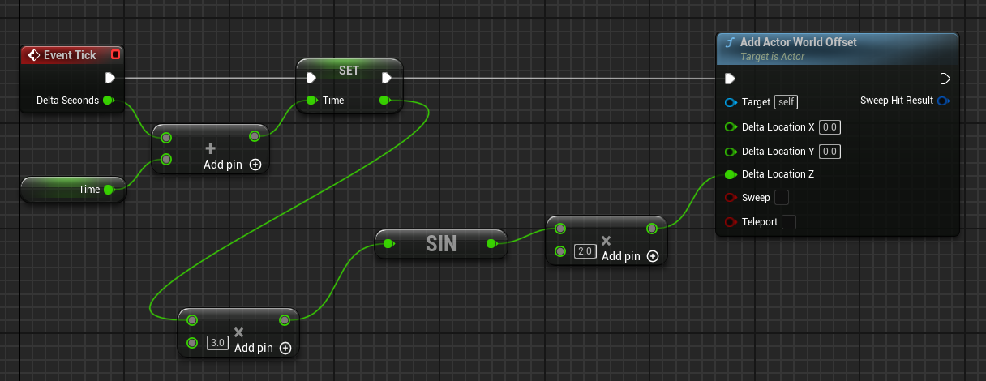

// Hard-Coded

Running_Time += DeltaTime; // Made a member variable of AItem in Items.h

float Delta_Z = 2.0f * FMath :: Sin( Running_Time * 2.0f ) ; // Here Adding in Angle will speed up the sine wave So Process will hapen quickly while adding in sine answer will increase the amplitude of the offset.

AddActorWorldOffset(FVector(0.0f, 0.0f, Delta_Z));

DRAW_SPHERE_SINGLE_FRAME( GetActorLocation( ) )

DRAW_VECTOR_SINGLE_FRAME( GetActorLocation( ) , GetActorLocation( ) + GetActorForwardVector( ) * 100.0f )

// OR Initialize Members

Amplitude = 2.0f; // The method of initializing it in Constructor would be less-efficient as it will take 1 more step rather than direct variable initialization in "private" OR Constructor Initializer List.

In Items.h 🡪 class SLASH_API AItem : public AActor

private:

float Running_Time ;

float Amplitude = 0.25f ;

float Time_Constant = 0.5f;

Running_Time += DeltaTime;

float Delta_Z = 2.0f * FMath :: Sin( Running_Time * 2.0f ) ; // sin period = 2*pi / k ;

AddActorWorldOffset(FVector(0.0f, 0.0f, Delta_Z));

DRAW_SPHERE_SINGLE_FRAME( GetActorLocation( ) )

DRAW_VECTOR_SINGLE_FRAME( GetActorLocation( ) , GetActorLocation( ) + GetActorForwardVector( ) * 100.0f )

* **To Expose C++ Variables to Blueprints :-**

UPROPERTY is a macro used to declare properties in classes derived from UObject . UPROPERTY provides various functionalities and metadata that can affect how properties behave and how they are handled by the engine. Like UPROPERTY( EditAnywhere )

EditDefaultsOnly 🡪 We can edit it but only in the default Blueprint.

EditInstanceOnly 🡪 We can edit and see it only using the Instance.

EditAnywhere 🡪 It gives flexibility as it is editable using both default and instances.

But it is least restrictive like if we changed the value in default blueprint without overwriting it in instance one so both are changed alongside ; but if we changed the default one in instance so changes of default blueprint did not take place in instance as it is manually overwritten unless resetted the values.

* **To Expose Variables Only NOT Editable :-**

VisibleDefaultsOnly 🡪 Indicates that this property is only visible in property windows for archetypes, and cannot be edited.

In our example :- This Specifier does not have its own Tick function as its associated with Instance so we can not see it being updated.

VisibleInstanceOnly 🡪 Indicates that this property is only visible in property windows for instances, not for archetypes, and cannot be edited.

In our example :- This Specifier is Instance one so it has its own Tick function so the Running_Time can be seen being updated.

VisibleAnywhere 🡪 Indicates that this property is visible in all property windows, but cannot be edited.

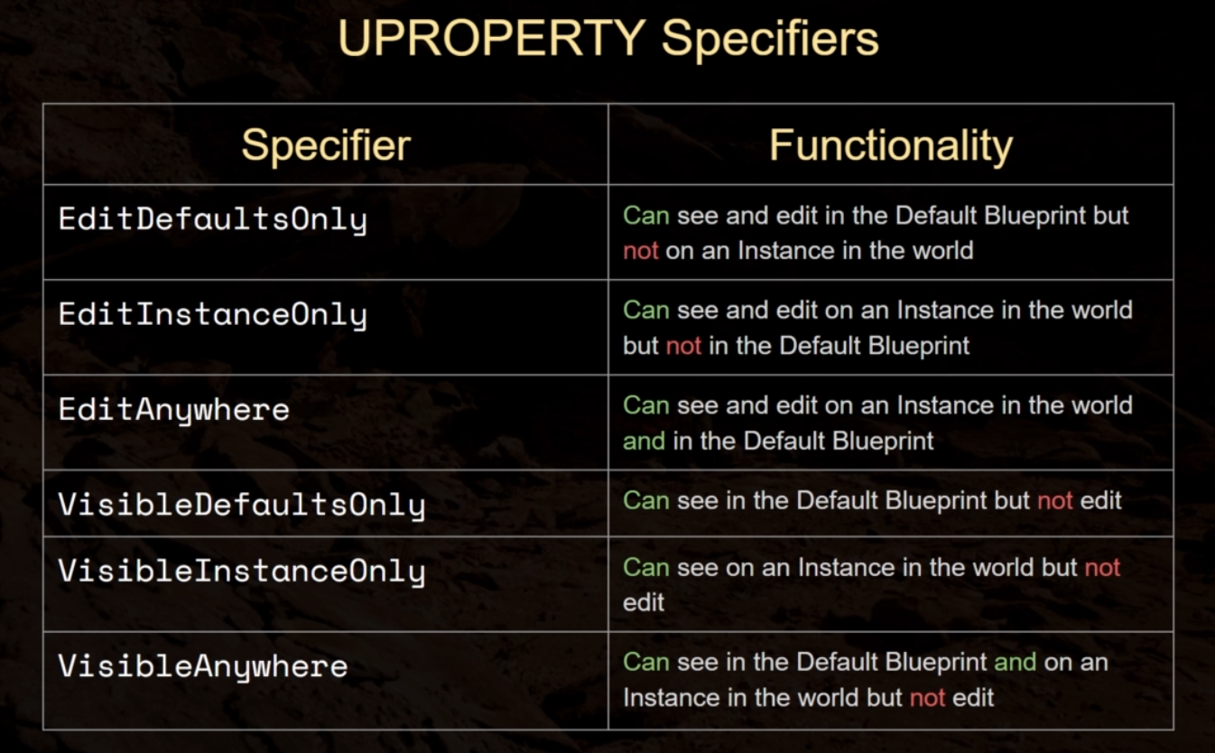

* **To Expose variables to Event Graph :-**

**Note :-** In order to use Blueprint Specifiers directly ; the members can’t be “private” so move them to “protected” section. As then it will potentially compromise ; the encapsulation and data integrity of the class.

BlueprintReadOnly 🡪 This property can be read by Blueprints, but not modified. This Specifier is incompatible with the BlueprintReadWrite Specifier.

BlueprintReadWrite 🡪 This property can be read or written from a Blueprint. This Specifier is incompatible with the BlueprintReadOnly Specifier.

UPROPERTY(EditAnywhere, BlueprintReadWrite )

However if you still want to expose a property as read-write from within Blueprints while keeping it private in C++, you can use the AllowPrivateAccess meta specifier which enables access to the private property for reflection purposes.

UPROPERTY( VisibleInstanceOnly , BlueprintReadOnly , meta = ( AllowPrivateAccess = "true" ) )

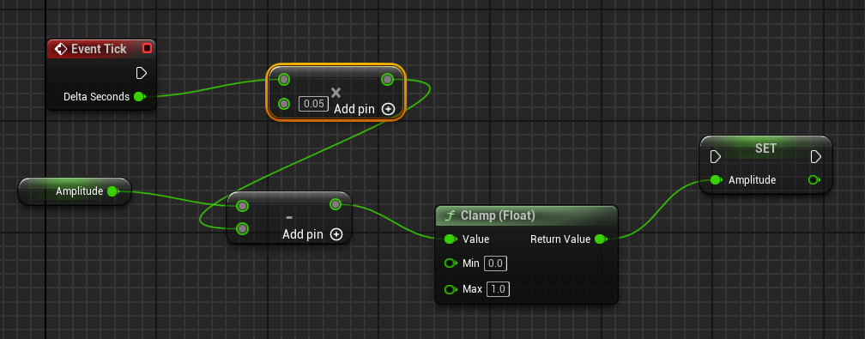

// Clamp() function is used to restrict a value within a specified range. It ensures that a given value stays within a specified minimum and maximum bounds. If the value provided to Clamp() is outside the specified range, it will be "clamped" or adjusted to fit within that range.

* **To Change the name of Category in Blueprint and Instance Details :-**

UPROPERTY(EditAnywhere, BlueprintReadWrite , Category = "Sine Parameters" )

* **To Expose Functions to Blueprint Event Graph :-**

BlueprintCallable 🡪 It makes the function executable  in a Blueprint or Level Blueprint graph with an input and output execution pin.

BlueprintPure 🡪 It makes the function only retrieve/input its value in Blueprint or Event Graph but it can’t change the properties of another actor.

UFUNCTION(BlueprintPure)

float TransformedSine( );

UFUNCTION( BlueprintPure )

float TransformedCosine( );

float AItem::TransformedCosine()

{

return Amplitude * FMath :: Cos(Running_Time * Time_Constant);

}

* **To Change Type using Template Functions :-**

**Note :-** Some Built-in Members doesn’t have the overloaded functions so template function won’t be called on that like below FRotator doesn’t support division.

template<typename T> // In “protected” Section

T Avg(T First, T Second);

template<typename T>

inline T AItem::Avg(T First, T Second)

{

return ( First + Second ) / 2 ;

}

int32 AvgInt = Avg<int32>(4, 6);

UE_LOG( LogTemp , Warning , TEXT("Avg of 4 and 6 is %d") , AvgInt )

FVector AvgVector = Avg<FVector>(GetActorLocation(), FVector :: ZeroVector);

DRAW_POINT_SINGLE_FRAME(AvgVector);

FRotator AvgRotator = Avg<FRotator>(GetActorRotation( ), FRotator :: ZeroRotator ); => Not Supported

* **To Add Components :-**

Via Blueprints ; Open the viewport and add the component you like OR drop from the content browser.

// In “private” Section

UPROPERTY( VisibleAnywhere )

UStaticMeshComponent* ItemMesh ;

// In “Constructor” Of Item

ItemMesh = CreateDefaultSubobject<UStaticMeshComponent>(TEXT("ItemMeshComponent")); // Unreal Engine uses factory functions for pointers rather than "new".

RootComponent = ItemMesh ; // Here we replace the Rootcomponent with ItemMesh for DefaultSceneRootComponent so Unreal's garbage collection system will see that since RootComponent points nothing so will delete its pointer automatically.

# CHAPTER 07 :-

* **Setting up Pawn using Capsule Component :-**

Since mesh is made up of large number of polygons ; so checking collision against mesh will be much expensive operation ; So we use a more basic shape like Capsule used as the simple collision representation for pawn classes.

#include <Components/CapsuleComponent.h>

#include "Bird.generated.h" // The generated.h must be the final header file else compiler will give error as when UE5 will include genereated.h ; pre-processor will paste in auto-generated tons of code and integrate it with reflection system.

private:

UPROPERTY( VisibleAnywhere )

UCapsuleComponent* Capsule ;

ABird::ABird()

{

PrimaryActorTick.bCanEverTick = true;

Capsule = CreateDefaultSubobject<UCapsuleComponent>(TEXT("Capsule"));

//RootComponent = Capsule ; // OR

SetRootComponent(Capsule);

Capsule -> SetCapsuleHalfHeight(20.0f);

Capsule -> SetCapsuleRadius(15.0f);

}

* **Forward Declaration :-**

Since we only need the UCapsuleComponent but all the other code will also be included with the header file and when we include “Bird.h” in “Bird.cpp” so it will again have to include the same header file ; likewise this in a large project will result in **code bloat** which can slow down compile time a great deal. Also if we include 2 header files in each other which will give error of Circular Dependency like “Weapon.h” in “Warrior.h” and “Warrior.h” in “Weapon.h” . So only declare header file where you need it or using its instance.

Forward declaration is a technique used in programming, like in 5 (UE5), to declare a class or struct without fully defining it. Instead of including the entire header file where the class or struct is defined, you simply declare its existence thus reducing compile time and avoiding unnecessary dependencies.

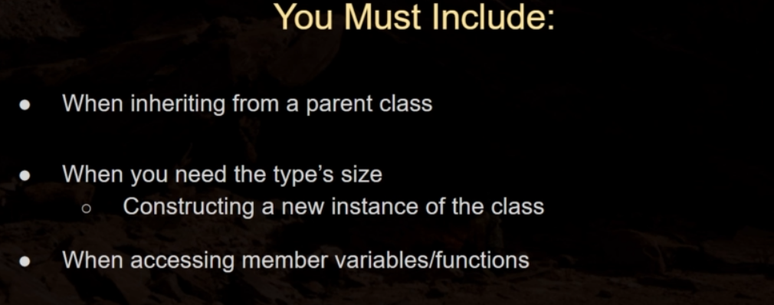

class UCapsuleComponent* Capsule ; // Forward Declaration in “Bird.h”

UCapsuleComponent* Second_Capsule; // Will not give error as forward declare above.

OR

class UCapsuleComponent ; // You can declare after declaraing all header files.

#include <Components/CapsuleComponent.h> // Included in “Bird.cpp” where we use its instance

Capsule = CreateDefaultSubobject<UCapsuleComponent>(TEXT("Capsule"));

* **Setup SkeletalMeshComponent :-**

class USkeletalMeshComponent;

UPROPERTY( VisibleAnywhere )

USkeletalMeshComponent* BirdMesh;

#include "Components/SkeletalmeshComponent.h" // Included in “Bird.cpp”

BirdMesh = CreateDefaultSubobject<USkeletalMeshComponent>(TEXT("BirdMesh"));

BirdMesh -> SetupAttachment(GetRootComponent());

* **To Map The Controller For Initial Building Inputs (Old) :-**

AutoPossessPlayer = EAutoReceiveInput :: Player0 ; // To Posses Pawn ( In Constuctor )

First go to Project Settings and Engine 🡪 Input 🡪 Axis Mapping then Assign Keys :-

protected:

void MoveForward(float Value);

// We can give the function any name ; but we must give parameter as **float** as it is the type of function which can be bound to axis mapping ; Once done , we suddenly have the binding between Axis mapping and function ( which is called per every frame )

void ABird::MoveForward(float Value)

{

UE_LOG(LogTemp, Warning, TEXT("Value = %f"), Value); // Value = ( 1.0 OR Scale ) when TRUE ; 0.0 for False

}

void ABird::SetupPlayerInputComponent(UInputComponent* PlayerInputComponent)

{

Super::SetupPlayerInputComponent(PlayerInputComponent);

//PlayerInputComponent -> BindAxis(TEXT("MoveForward")); // OR

PlayerInputComponent -> BindAxis(FName("MoveForward") , this , &ABird::MoveForward ) ; // 1st Name of Axis Mapping to link ; 2nd User Class pointer ( User Class exists in higher level in hierarchy in UE and Bird Pawn is Descendant of that class so can pass its pointer ) ; 3rd User Object ( To which function we want to bind “Move Forward” function. )

}

* **Binding Enhanced Input ( New ) :-**

ShowDebugEnhancedInput 🡪 To check whether the actions and axis mapping is being triggered or not .

Also we an have different action keys depending on priority keys to handle collision between them.

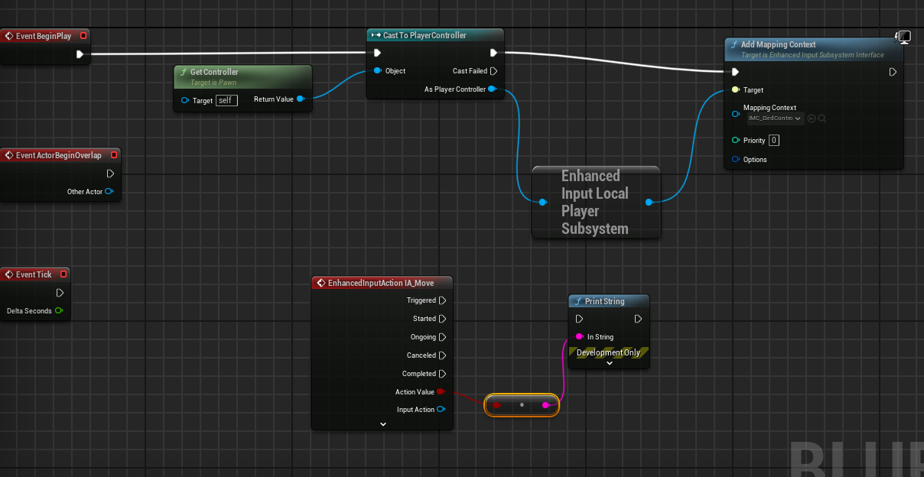

“In Bird.h”

#include "InputActionValue.h" // As FInputActionValue is a struct with not returning pointer so can't forward declare it hence we simply include in Bird.h before "Bird.generated.h"

class UInputMappingContext;

class UInputAction;

protected:

virtual void BeginPlay() override;

// Note:- We must choose the mapping context and Move action from the Blueprint Details or else pointer will give NULL and program will not run as intended.

UPROPERTY( EditAnywhere , BlueprintReadOnly , Category = "Input" )

UInputMappingContext* BirdMappingContext ;

UPROPERTY(EditAnywhere, BlueprintReadOnly, Category = "Input")

UInputAction* MoveAction;

void Move(const FInputActionValue& Value);

“In Bird.cpp”

#include "Components/InputComponent.h"

#include "EnhancedInputSubsystems.h"

#include "EnhancedInputComponent.h"

void ABird::BeginPlay()

{

Super::BeginPlay();

// OR Simply Controller ( as its in public section in UE 5.1) ( Also can declare directly )

if (APlayerController* PlayerController = Cast<APlayerController>(GetController()) )

{

UEnhancedInputLocalPlayerSubsystem* Subsystem = ULocalPlayer :: GetSubsystem<UEnhancedInputLocalPlayerSubsystem>( PlayerController -> GetLocalPlayer());

if (Subsystem)

{

Subsystem -> AddMappingContext(BirdMappingContext, 0); // Here 0 is priority key

}

}

}

void ABird::Move(const FInputActionValue& Value)

{

const bool CurrentValue = Value.Get<bool>(); // Has to be same type as IA_Move

if (CurrentValue)

{

UE_LOG(LogTemp, Warning, TEXT("IA_Move Trigerred"));

}

}

void ABird::SetupPlayerInputComponent(UInputComponent* PlayerInputComponent)

{

Super::SetupPlayerInputComponent(PlayerInputComponent);

// CastChecked will not only just Cast the input of UInputComponent to EnhancedInputComponent but if failed to do so will also crash the program.

if (UEnhancedInputComponent* EnhancedInputComponent = CastChecked<UEnhancedInputComponent>(PlayerInputComponent))

{

EnhancedInputComponent -> BindAction(MoveAction, ETriggerEvent :: Triggered, this, &ABird :: Move);

}

}

* **Adding Movement Input ( Old ) :-**

void ABird::MoveForward(float Value)

{

// Placed ( GetController() ) condition so that only that Pawn moves which has been possessed.

if ( ( GetController( ) != nullptr ) && (Value != 0.0f))

{

FVector Forward = GetActorForwardVector();

AddMovementInput(Forward, Value); // It will automatically detect whether value is 0 ( do nothing ) ; +ve ( Consider Original Vector ) ; -ve ( Consider Negative Vector )

}

}

**Note :-** AddMovementInput() passes the direction offset to movement component ; but since Pawns by default have no movement component ; so add new component in Blueprint “Floating Pawn Movement” . Now through it we can change movement properties also.

**MY CHANGEMENTS**

void ABird::MoveSideways(float Value)

{

if ((GetController()) && (Value != 0.0f))

{

FVector Sideway = GetActorRightVector() ;

AddMovementInput(Sideway, Value);

}

}

void ABird::MoveUpDown(float Value)

{

if ((GetController()) && (Value != 0.0f))

{

FVector UpDown = GetActorUpVector() ;

AddMovementInput(UpDown, Value);

}

}

void ABird::SetupPlayerInputComponent(UInputComponent* PlayerInputComponent)

{

Super::SetupPlayerInputComponent(PlayerInputComponent);

PlayerInputComponent -> BindAxis(FName("MoveForward"), this, &ABird::MoveForward);

PlayerInputComponent -> BindAxis(FName("MoveSideways"), this, &ABird::MoveSideways);

PlayerInputComponent -> BindAxis(FName("MoveUpDown"), this, &ABird::MoveUpDown);

}

* **Adding Movement Input ( Enhanced ) :-**

**Note:-** First include the "EnhancedInput” dependency in Slash.Build.cs and then Delete “Binaries , Saved and Intermediate” folder and regenerate Project Files and then Build mostly manually from VS.

void ABird::Move(const FInputActionValue& Value)

{

const float DirectionValue = Value.Get<float>(); // Has to be same type as IA_Move

if ((GetController() != nullptr) && (DirectionValue != 0.0f))

{

FVector Forward = GetActorForwardVector();

AddMovementInput(Forward, DirectionValue);

}

}

void ABird::SetupPlayerInputComponent(UInputComponent* PlayerInputComponent)

{

Super::SetupPlayerInputComponent(PlayerInputComponent);

if (UEnhancedInputComponent* EnhancedInputComponent = CastChecked<UEnhancedInputComponent>(PlayerInputComponent))

{

EnhancedInputComponent -> BindAction(MoveAction, ETriggerEvent :: Triggered, this, &ABird :: Move); } }

MY Moventment Function :-

void ABird::Move(const FInputActionValue& Value)

{

const FVector2D MyVector = Value.Get<FVector2D>();

if ( ( GetController() ) && ( ( MyVector.X != 0.0f ) || ( MyVector.Y != 0.0f ) ) ) {

FVector Forward = GetActorForwardVector();

AddMovementInput(Forward, MyVector.X);

FVector Right = GetActorRightVector();

AddMovementInput(Right, MyVector.Y);

}

}

* **Adding Camera and Spring Arm Components :-**

Add the “Camera” and “Spring Arm” components to Pawn Blueprint class and then attatch the spring arm camera to Capsule component and Camera to spring arm component by holding the menu button and dropping on it. Then you can adjust accordingly camera accordingly to you spring arm. It is usually recommended to include a Spring Arm to automatically control how the camera handles situations where it becomes obstructed by level geometry or other objects so it ZOOMS the object accordingly.

“In C++ ; if you get the error that details of newly added components are not showing up so change the component variable name ; close UE and build from VS. It’s a bug.”

class USpringArmComponent;

class UCameraComponent;

private:

UPROPERTY( VisibleAnywhere )

USpringArmComponent* SpringArm;

UPROPERTY(VisibleAnywhere)

UCameraComponent* ViewCamera;

#include "GameFramework/SpringArmComponent.h"

#include "Camera/CameraComponent.h"

// In Constructor

SpringArm = CreateDefaultSubobject<USpringArmComponent>(TEXT("CameraBoom"));

SpringArm -> SetupAttachment(GetRootComponent());

SpringArm -> TargetArmLength = 300.0f;

SpringArm -> SetRelativeRotation(FRotator(0.f, -40.f, 0.f));

ViewCamera = CreateDefaultSubobject<UCameraComponent>(TEXT("ViewCamera"));

ViewCamera -> SetupAttachment(SpringArm);

* **Adding Rotation to Controller (Old) :-**

First add the axis bindings for Mouse like where MouseX refers to horizontal motion of mouse and MouseY refers to vertical motion. Now create the Blueprint then select Blueprint self to Set “Use Controller Rotation Pitch and Yaw” to True.

Here we bind “MouseX” with Yaw ( Y-Rotation ) and “MouseY” with Pitch ( X-Rotation ) as the Unreal World Positions are in that direction i.e. their X refers vertical and Y refers horizontal. Also we changed the scale of MouseY to -1.0 so to negate the motion i.e. when Mouse is moved to below ; Controller also rotates below instead of UP force.

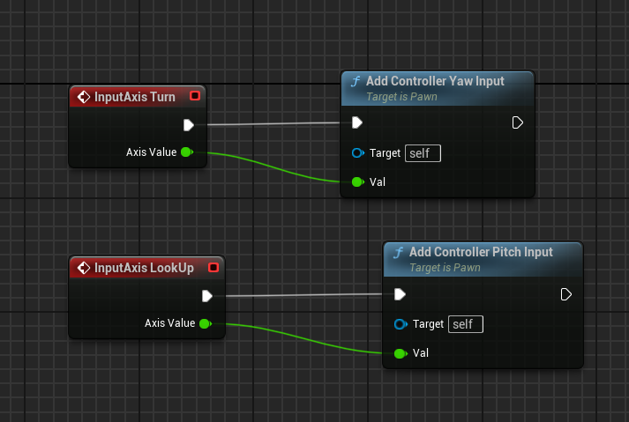

void ABird::Turn(float Value)

{

AddControllerYawInput(Value);

}

void ABird::LookUp(float Value)

{

AddControllerPitchInput(Value);

}

void ABird::SetupPlayerInputComponent(UInputComponent* PlayerInputComponent)

{

Super::SetupPlayerInputComponent(PlayerInputComponent);

PlayerInputComponent -> BindAxis(FName("MoveForward"), this, &ABird::MoveForward);

PlayerInputComponent -> BindAxis(FName("MoveSideways"), this, &ABird::MoveSideways);

PlayerInputComponent -> BindAxis(FName("Turn"), this, &ABird::Turn);

PlayerInputComponent -> BindAxis(FName("LookUp"), this, &ABird::LookUp); }

* **Adding 2D-Rotation to Camera ( Enhanced ) :-**

**Note:-** Remember to update the input action through Blueprint OR else will give null pointer to functions as Blueprints are executed 1st then C++ code.

UPROPERTY(EditAnywhere, BlueprintReadOnly, Category = "Input" )

UInputAction* LookAction;

void Look(const FInputActionValue& Value);

void ABird::Look(const FInputActionValue& Value)

{

const FVector2D LookAxisValue = Value.Get<FVector2D>();

if( GetController() )

{

AddControllerYawInput(LookAxisValue.X);

AddControllerPitchInput(LookAxisValue.Y);

}

}

void ABird::SetupPlayerInputComponent(UInputComponent* PlayerInputComponent)

{

Super::SetupPlayerInputComponent(PlayerInputComponent);

if (UEnhancedInputComponent* EnhancedInputComponent = CastChecked<UEnhancedInputComponent>(PlayerInputComponent))

{

EnhancedInputComponent -> BindAction(MoveAction, ETriggerEvent :: Triggered, this, &ABird :: Move);

EnhancedInputComponent -> BindAction(LookAction, ETriggerEvent :: Triggered, this, &ABird :: Look);

}

}

* **Setting Default Pawn :-**

If we open another map instead of that we are configuring ; then we can also see the Deafult_Pawn sphere which the system automatically loads in and also if we fly our pawn Bird out of the section to other unloaded section ; then it will automatically be unloaded as Default_Pawn is set as referenced one ; so to fix these things :

Create a Blueprint class of Game Mode and then open it and set default pawn class to BP_Bird ; and then in “World Settings” change the GameMode Override to that BP_BirdGameMode. Now wherever you position your camera OR your Game Start is placed from there Bird Pawn will automatically be possessed.

# CHAPTER 08 :-

* **Setting Up Character Input(Old) :-**

It is similar to the pawn old movement input action.

void ASlashCharacter::MoveForward(float Value)

{

if ((GetController()) && (Value != 0.0f)) {

FVector Forward = GetActorForwardVector();

AddMovementInput(Forward, Value);

}

}

void ASlashCharacter::MoveSideways(float Value)

{

if ((GetController()) && (Value != 0.0f)) {

FVector Right = GetActorRightVector();

AddMovementInput(Right, Value);

}

}

void ASlashCharacter::SetupPlayerInputComponent(UInputComponent* PlayerInputComponent)

{

Super::SetupPlayerInputComponent(PlayerInputComponent);

PlayerInputComponent -> BindAxis(FName("MoveForward"), this, &ASlashCharacter :: MoveForward);

PlayerInputComponent -> BindAxis(FName("MoveSideways"), this, &ASlashCharacter :: MoveSideways);

}

* **Directional Enhanced Input Character Movement (New) :-**
* **Adding Character Camera and Spring Arm :-**

**Note:-** Set the UseControllerYaw , pitch and roll to false so it doesn’t automatically inherit it from the parent. And then set the UsePawnControllerRotation to True in Blueprint so that only the SpringArm rotates relatively with the Controller but doesn’t levitate the character mesh or capsule component itself.

class USpringArmComponent;

class UCameraComponent;

private:

UPROPERTY(VisibleAnywhere)

USpringArmComponent* CameraBoom;

UPROPERTY(VisibleAnywhere)

UCameraComponent* ViewCamera;

#include "GameFramework/SpringArmComponent.h"

#include "Camera/CameraComponent.h"

ASlashCharacter::ASlashCharacter()

{

PrimaryActorTick.bCanEverTick = true;

// Must set these to false so that character doesn’t inherit in Blueprint.

bUseControllerRotationPitch = false;

bUseControllerRotationYaw = false;

bUseControllerRotationRoll = false;

CameraBoom = CreateDefaultSubobject<USpringArmComponent>(TEXT("CameraBoom"));

CameraBoom -> SetupAttachment(GetRootComponent());

CameraBoom -> TargetArmLength = 300.0f;

ViewCamera = CreateDefaultSubobject<UCameraComponent>(TEXT("ViewCamera"));

ViewCamera -> SetupAttachment(CameraBoom);

}

* **Rotation Matrix For Controller Direction:-**

Now we want the character to move forward in the direction of controller forward vector not its forward vector . But since Controllers only have Rotation no Location so we can use Rotation Matrix multiplication with Vector to find the corresponding vector to Controller.

void ASlashCharacter::MoveForward(float Value)

{

if ((GetController()) && (Value != 0.0f))

{

// Find out which way is Controller Forward

const FRotator ControlRotation = GetControlRotation();

const FRotator YawRotation(0.0f, ControlRotation.Yaw, 0.0f); // As character can only move sideways not updown so we only need to get the X-axis( Unreal's Y-Axis ) Rotation

const FVector Direction = FRotationMatrix(YawRotation).GetUnitAxis( EAxis :: X ); // This will return the single Unit Vector for direction corresponding to X-axis( Forawrd , Backward ) with Yaw Rotation.

AddMovementInput(Direction, Value);

}

}

void ASlashCharacter::MoveSideways(float Value)

{

if ((GetController()) && (Value != 0.0f))

{

// Find out which way is Right

const FRotator ControlRotation = GetControlRotation();

const FRotator YawRotation(0.0f, ControlRotation.Yaw, 0.0f);

const FVector Direction = FRotationMatrix(YawRotation).GetUnitAxis(EAxis :: Y); // Same here Get the Updated X-Axis( Yaw Rotation ) But corresponding to Right , Left ( Y-Axis in Unreal )

AddMovementInput(Direction, Value);

}

}

Also after this enable the “Orient Rotation to Movement” in Character Movement Blueprint so the character also faces in the same direction at Rotation Rate when rotated. OR from C++

#include "GameFramework/CharacterMovementComponent.h"

GetCharacterMovement() -> bOrientRotationToMovement = true ;

GetCharacterMovement() -> RotationRate = FRotator(0.0f, 400.0f, 0.0f);

* **Setting Up Echo Hair :-**

**Note:-** First include the "[HairStrandsCore](https://docs.unrealengine.com/4.26/en-US/API/Plugins/HairStrandsCore/index.html)” ( but after “Niagara” as sometimes error may occur) dependency in Slash.Build.cs and then Delete “Binaries , Saved and Intermediate” folder and regenerate Project Files and then Build mostly manually from VS.

and if error occurs again so also include the 2 Groom plug-ins in Unreal Engine

class UGroomComponent;

UPROPERTY(VisibleAnywhere, Category = "Hair")

UGroomComponent* Hair;

UPROPERTY(VisibleAnywhere , Category = "Hair")

UGroomComponent* Eyebrows;

#include "GroomComponent.h"

ASlashCharacter::ASlashCharacter()

{

Hair = CreateDefaultSubobject<UGroomComponent>(TEXT("Hair"));

Hair -> SetupAttachment(GetMesh());

Hair -> AttachmentName = FString("Head"); // It takes as socket so used FString(“Head”)

Eyebrows = CreateDefaultSubobject<UGroomComponent>(TEXT("Eyebrows"));

Eyebrows -> SetupAttachment(GetMesh());

Eyebrows -> AttachmentName = FString("Head");

}

* **Changing Echo’s Hair Color :-**

First duplicate the “MI_EchoGroomComponent” ( Material Instance ) and then you can modify the duplicated color and set the Material to that changed GroomComponent to customize the Echo’s hair color.

# CHAPTER 09 :-

* **Setting the Animation Blueprint :-**

First create a Animation Blueprint of your Skeletal Mesh and then set the Animation Mode in your Blueprint Character class from “Animation Asset” to “Animation Blueprint 🡪 ABP_Slash” . Now in Animation Blueprint Class ; 1st set the animation to loop which you want to use and then in event graph create some variables and build logic like below and set the State Nodes accordingly:-

**“Stephen’s Way”**

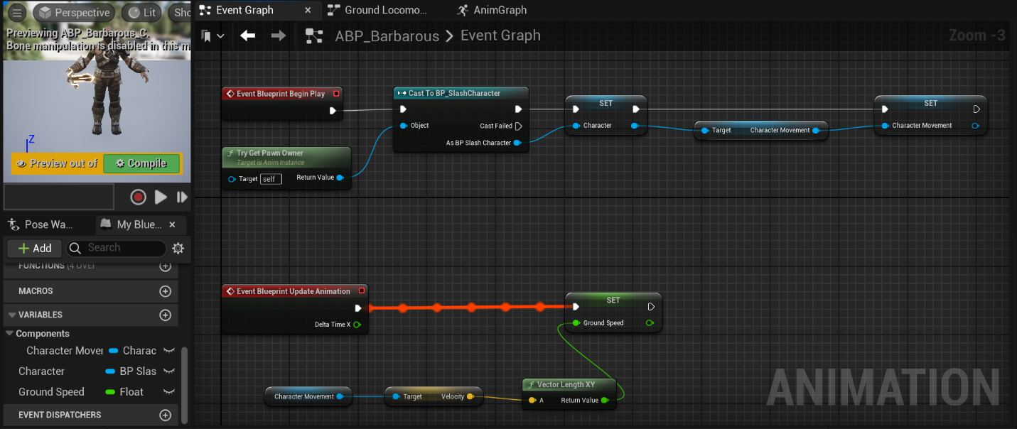

We casted to “Character Blueprint” to access the Character Movement Varaibles as the parent class ( Pawn ) can’t be directly link to child class ( Character ). Also the “Target” Character movement linked to “Character Set” is not the variable but the Character Movement Component Object Reference of BP_SlashCharacter.

**Note:-** This will run properly but while closing playing game will give runtime error like :-

Blueprint Runtime Error: "Accessed None trying to read property Character Movement". Node: Set Ground Speed Graph: EventGraph Function: Execute Ubergraph ABP Barbarous Blueprint: ABP_Barbarous

Firstly Begin Play will run but since Casting is an expensive process so “Tick” function will be executed which will try to access “Character Movement” variable without initially setting it so giving “null pointer”.

**“Solution”** OR you can also remove “Begin Play” and directly set all the upper remaining nodes to “Is Not Valid”.

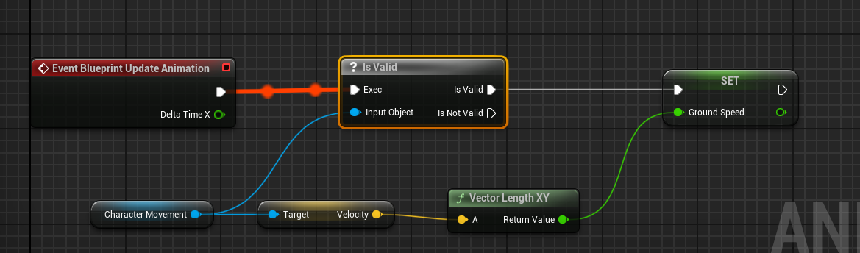

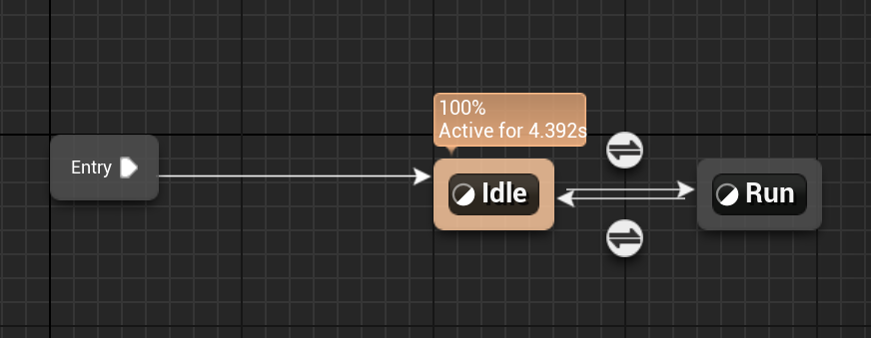

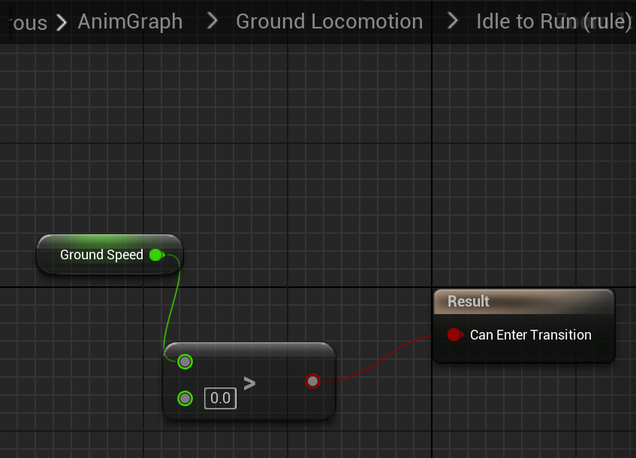

For Run to Idle transition 🡪 if ( GroundSpeed == 0 )

* **Changing Inherited AnimInstance For C++ :-**

Create a new C++ class for AnimInstance. Then define the overriding functions by yourself :-

**“In SlashAnimInstance.h”**

class SLASH_API USlashAnimInstance : public UAnimInstance

{

GENERATED_BODY()

public:

virtual void NativeInitializeAnimation() override;

virtual void NativeUpdateAnimation(float DeltaTime) override;

protected:

UPROPERTY(BlueprintReadOnly);

class ASlashCharacter* SlashCharacter;

UPROPERTY(BlueprintReadOnly , Category = "Movement");

class UCharacterMovementComponent* SlashCharacterMovement;

UPROPERTY(BlueprintReadOnly, Category = "Movement");

float GroundSpeed;

};

**“In SlashAnimInstance.cpp”**

#include "GameFramework/CharacterMovementComponent.h" // Need to include this again OR will give error

#include "Kismet/KismetMathLibrary.h" // Static library just perform calculation and give result

void USlashAnimInstance :: NativeInitializeAnimation() // Similiar to Animation BeginePlay()

{

Super :: NativeInitializeAnimation() ;

SlashCharacter = Cast<ASlashCharacter>( TryGetPawnOwner() );

if (SlashCharacter)

{

SlashCharacterMovement = SlashCharacter -> GetCharacterMovement();

}

}

void USlashAnimInstance :: NativeUpdateAnimation(float DeltaTime)

{

Super :: NativeUpdateAnimation(DeltaTime);

if( SlashCharacterMovement )

{

GroundSpeed = UKismetMathLibrary :: VSizeXY(SlashCharacterMovement -> Velocity );

}

}

* **Setting Up Jumping :-**

First create an Action Binding in Engine 🡪 Input . Then :-

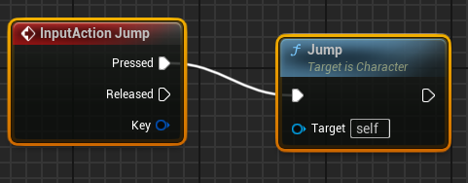

OR In C++ :-

PlayerInputComponent -> BindAction(FName("Jump"), IE_Pressed, this, &ACharacter :: Jump);// Called Actor class Character Jump already existing not Slash one as we have not overidden that.

* **Jump Animation :-**

First setup Mixamo Animation then for jumping via Blueprint make our own C++ variable.

UPROPERTY(BlueprintReadOnly, Category = "Movement");

bool IsFalling;

if( SlashCharacterMovement )

{

GroundSpeed = UKismetMathLibrary :: VSizeXY(SlashCharacterMovement -> Velocity );

IsFalling = SlashCharacterMovement -> IsFalling();

}

If character isFalling so ( transition to Air ) ; if ( NOT isFalling ) so transition to Land.

Then create a new Cache Pose in AnimGraph blueprint so that “Ground Locomotion” as whole can directly be used in another state by using **“Use Cached Pose Ground Locomotion”**.

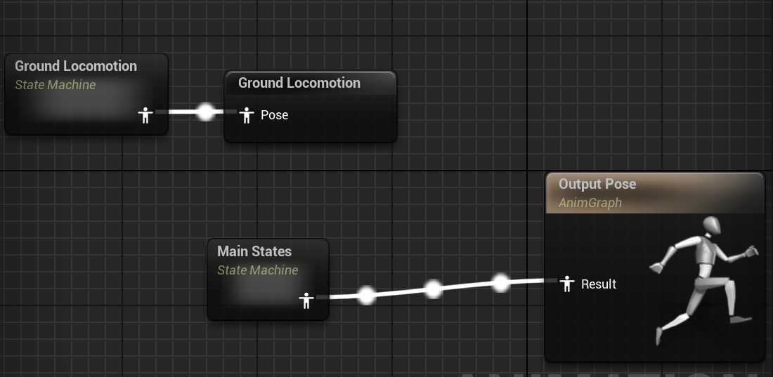

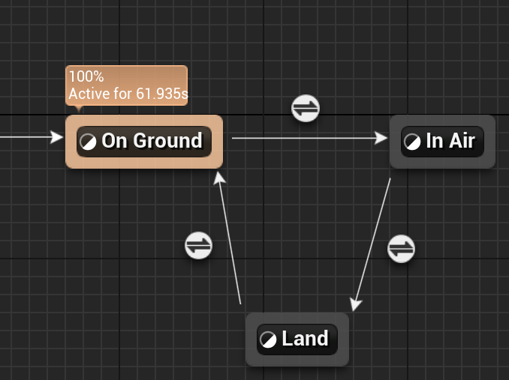

If error occurs so can also add another Rule from ( Land to On Ground ) and then Make this condition on that Rule True. 🡪 Automatic Rule Based of Sequence Player in State.

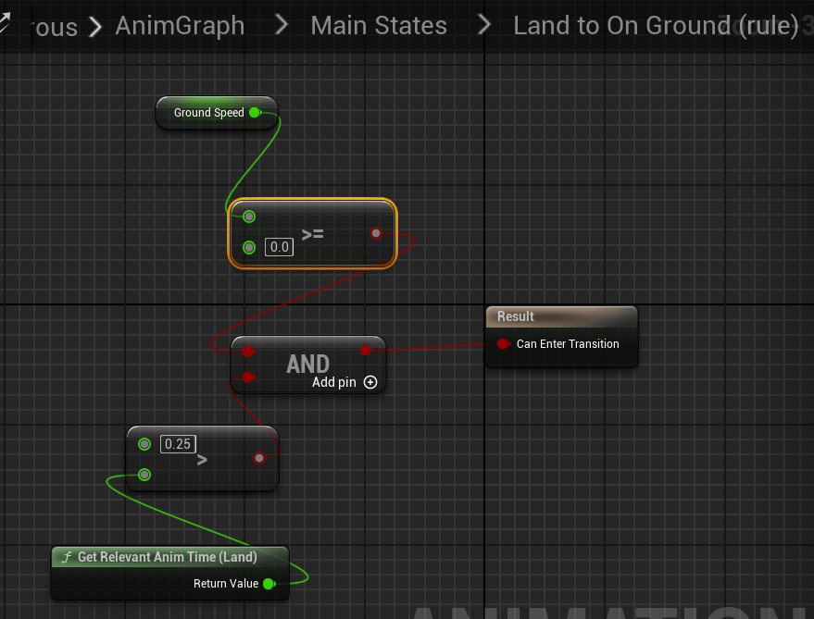

If Animation elapsed time exceeds 0.25 or even if GroundSpeed becomes greater than 0 or equal to 0 ; so change state. ( Used equal cause if we jump without running at start so speed is already 0 so it will not transit and will just stop using Animation Blueprint )

* **Inverse Kinematics ( Tuning Animations ):-**

Inverse Kinematics is a method of solving complex eqs to move/bend a bone like in Robotics.

Here we are doing Sphere Tracing to detect the surface location ; start and end distance will be given and sphere will be traced within it and check for tunings.

Then which foot Z-surface is lower ; we are moving that leg’s ( pelvis bone ) down ; ( but firstly doing it with IK_bones or virtual_bones which are just like bones which don’t have any skin mesh attatched to them , like they are invisible so if we move them , it will do no motion in mesh. )

Then we for smooth movement ; we are interpolating the motion instead of just snapping.

First create a Control_Rig ; then create virtual_bones if there are no ik_bones 🡪 virtual_root bone first then under its hierarchy , we do virtual_virtual_left_foot. Import rig hierarchy in Control rig .Then blueprints are like these :-

**Blueprint have branches to check Boolean condition but control rigs have if-nodes.**

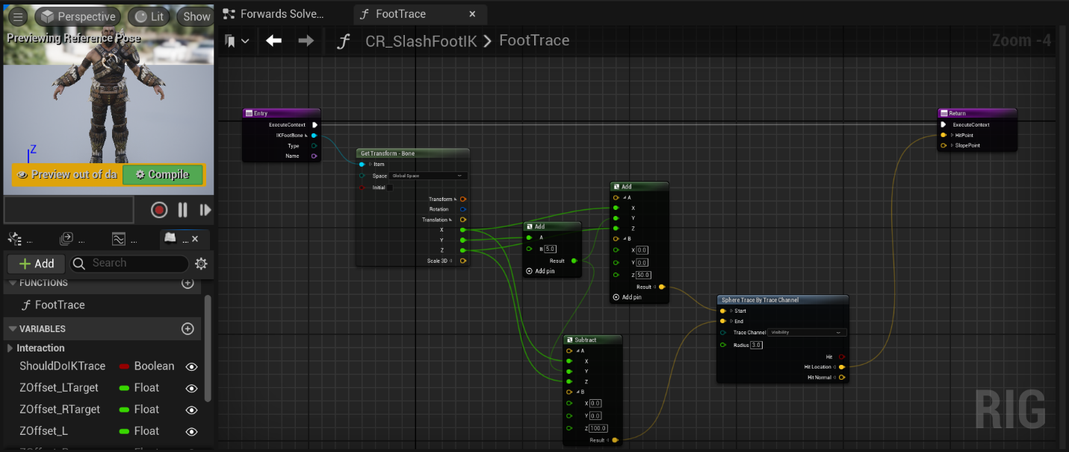

**In “visibility” channel ; it also includes those parts of surfaces below which are ignored by collision.**

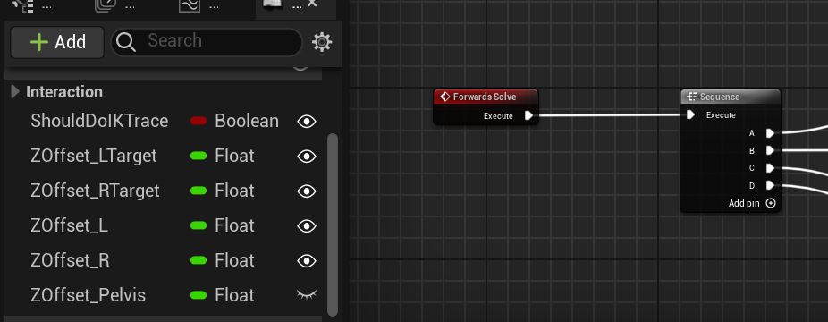

**Sequence made to run the Blueprints in an ordered sequence like A 🡪 B 🡪 C 🡪 D. ( ‘D’ will run in last )**

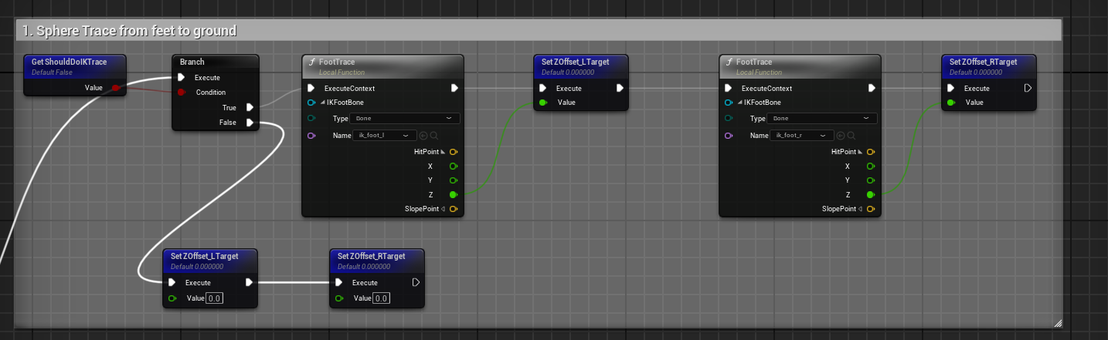

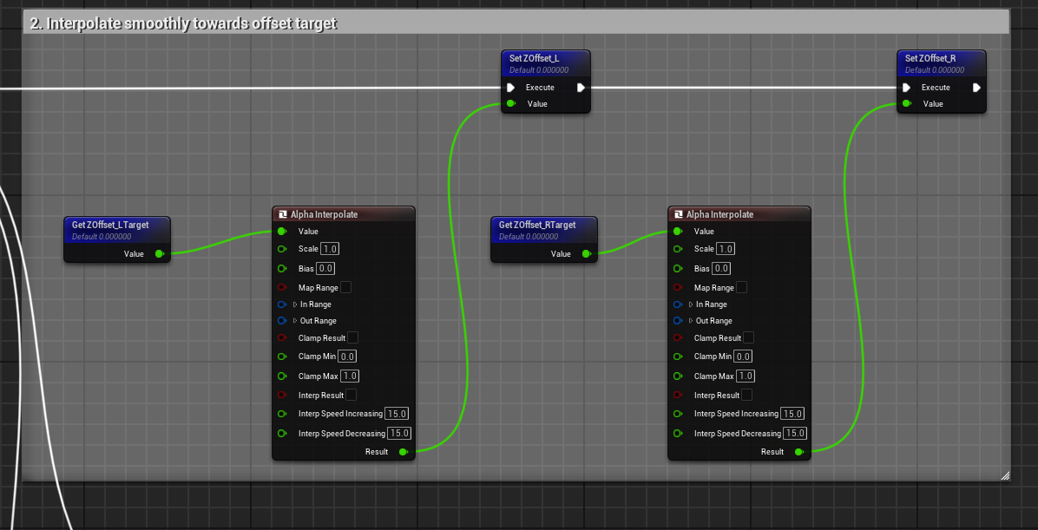

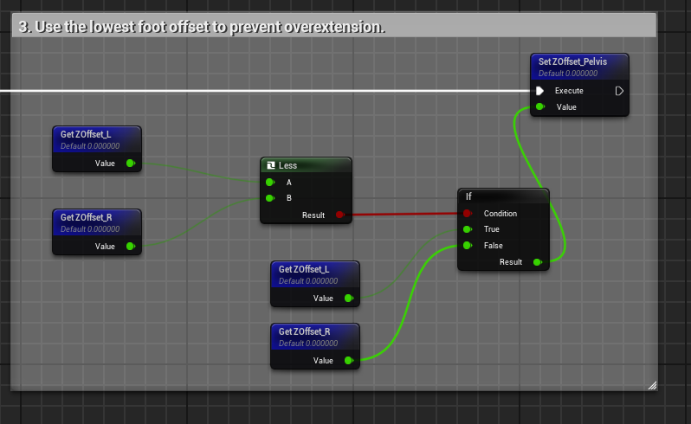

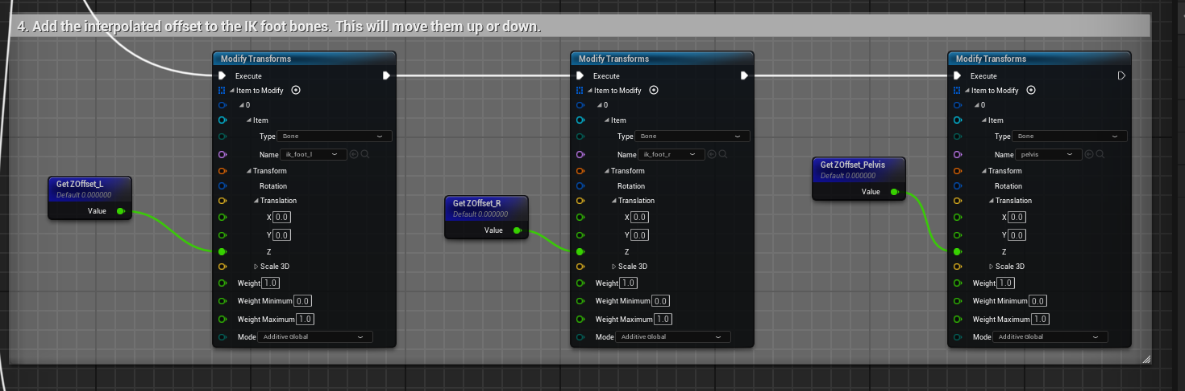

**To mark comments on Blueprints ; select the required nodes and then press “C” .**

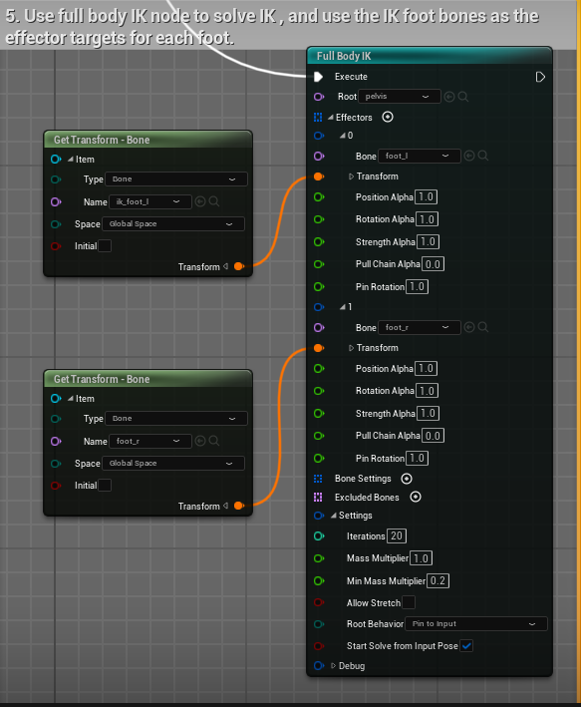

Here by mistake in “Transform” I had given input “foot_r” instead of “ik_foot_r”.

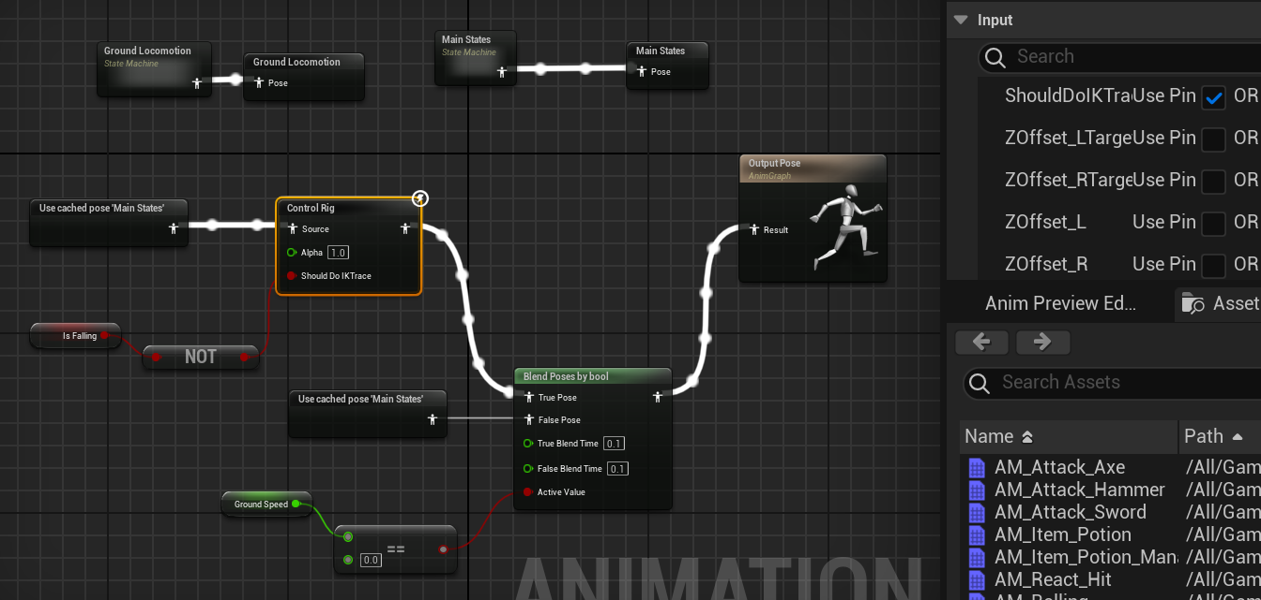

Now in “Animation Blueprint” make the main states ( cache pose also ) for multiple-usuage for conditional. ( And when GroundSpeed = 0 and isFalling is NOT True ) only then call the Control Rig Animation ; else call the normal one OR it may try to stick the feet each time even when jumping or running.

**MY CHANGES :-**

Firstly ; I changed the jumping animation to Air 🡪 Fall Loop 🡪 Land ; so that if character is falling continuously so Fall Loop function keeps on playing. ( i.e. for isFalling is True only )

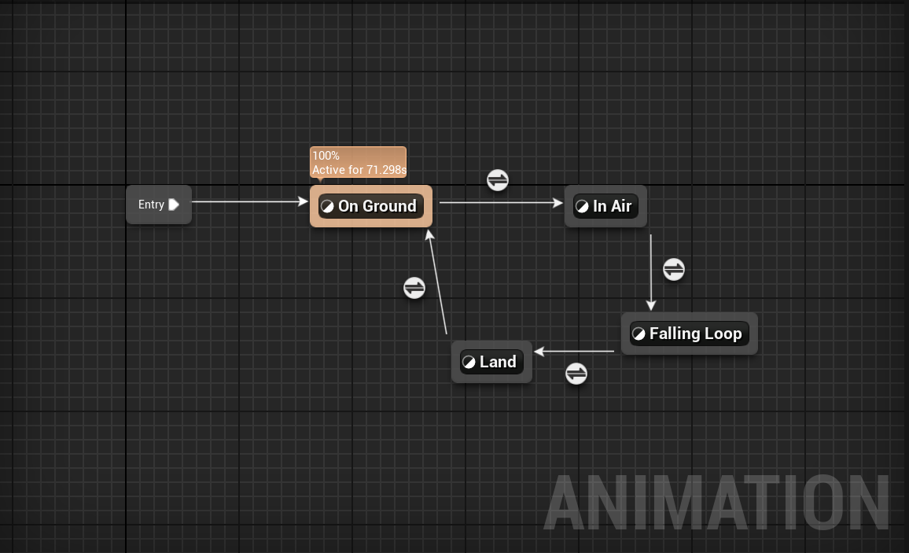

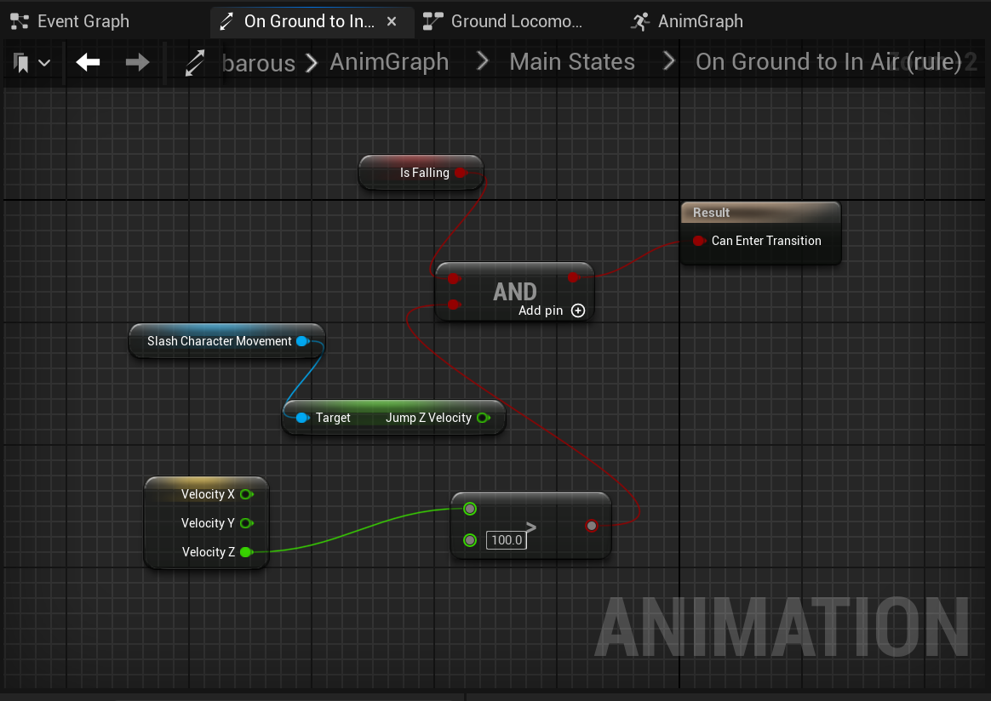

Also added the Foot Rotation according to Normal of Sloped Ground.

( Here the Z-axis in Add Vector refers to the location upto which sphere tracing is done. Like our world is +32 already at start in Z-axis )

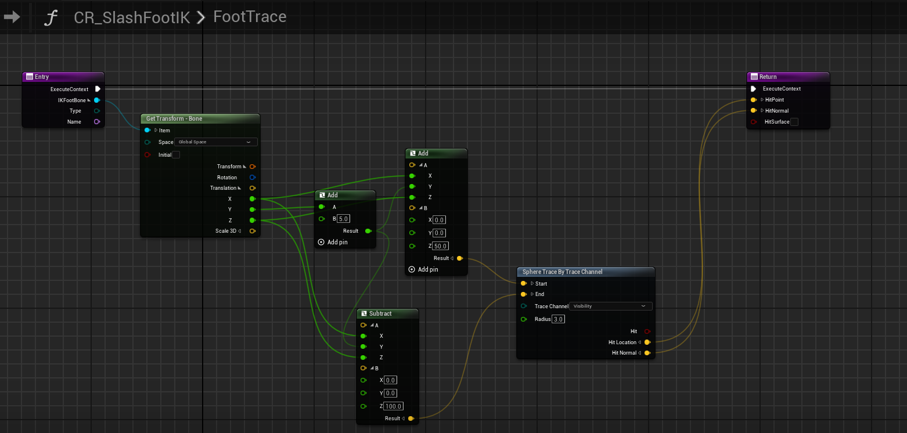

Now add that Normal Vector into separate variables for Left and Right Foot.

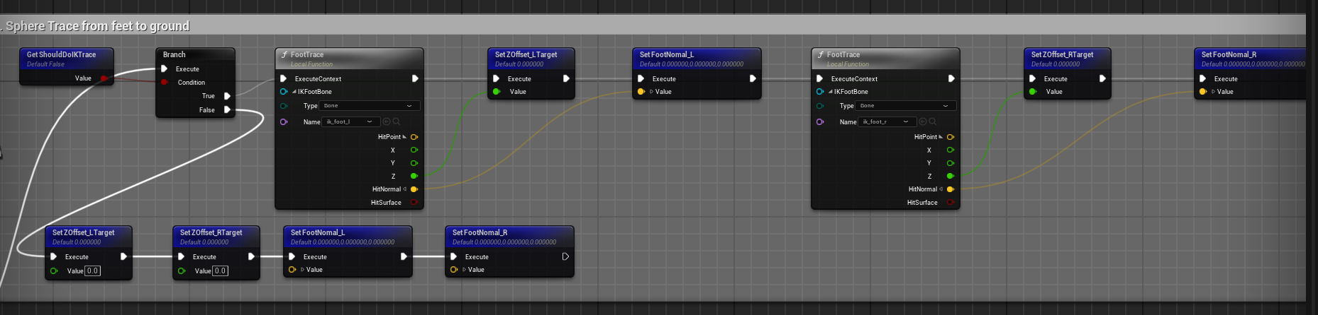

Then in last step just before transforming the original bones based on ik_ones ; add the aiming rotation of feet from Aim Math.

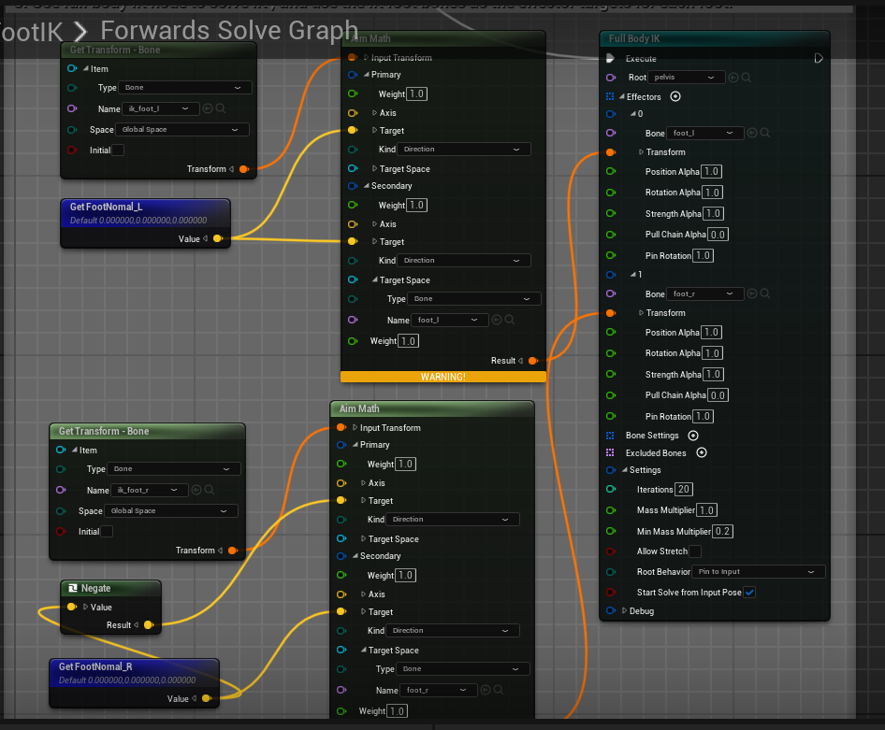

Here also I did “negate” as the Right foot was facing downwards.

# CHAPTER 10 :-

* **Collision Presets :-**

No Collision 🡪 Component will pass through objects. ( No responses )

Query Only ( No Physics Collision ) 🡪 Like ray casts , sweeps ( about to overlap ) or overlaps but no physics calculation like gravity , motion.

Physics Only ( No Query Collision ) 🡪 Only can simulate physics but no spatial queries( like capsule collision etc so body can move on being hit).

Collision Enabled ( Query and Physics ) 🡪 Both Enabled and most expensive .

Collision Custom Examples :-

Since our Character Capsule is a Pawn type so if make collision custom and in responses ignore “Pawn” so Character will not be blocked by that thing.

Our if we want a hidden door like through which our camera zooms but we can pass through so set “Pawn” to ignore but “Camera” to block.

OR on a body of ( Only physics no query ) if we want Camera not to be zoomed but our Leg IK queries to be calculated so set “Camera” to ignore collision so it will not be zoomed but set “Visibility” to block so it will be hit by surface and perform our hit results for IK legs.

* **Overlap Events :-**

Even if our character Capsule Component “Pawn” have Collision Enabled for all but if we set overlap for “BP_Item” ; it will start overlapping it.

Overlap is used to check the collision of Actor with another one like if we only need to have same overlap events for all actor so for this you can setup a new component by Adding Component Sphere Collision Component just like capsule component and if also want to see in game so uncheck “Hidden in Game” and use :-

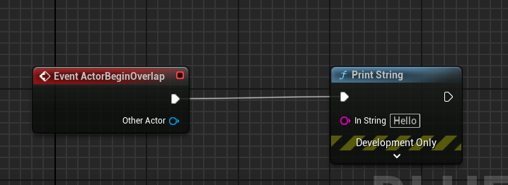

If want to check overlap only for certain actors so select that component and include in Blueprint like :-

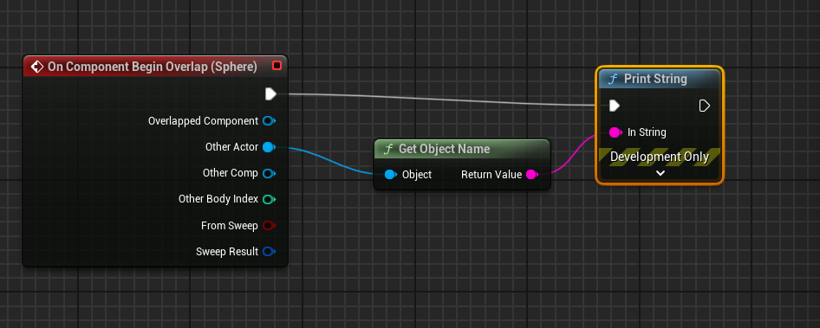

“Overlapped Component” 🡪 This will give the name of component whose is being overlapped.

“Other Actor” 🡪 This will give the name of Actor which is overlapping.

“Other Comp” 🡪 This will give the name of Component which is being overlapped ( Collision Cylinder for our Character which is Capsule Component MACRO.)

* **Delegates :-**

( Observer Pattern ) 🡪 We have an object “Subject” which have list pointer of all “Observers” in World ; so the goal if when an event occurs Subject loops through its list and calls the Callback() function for that “particular Observer”. Here it is designed in such a way that when Object is created ; it adds itself to subject’s list and specify what callback() function will be called.

Unreal Engine uses “Delegates” to implement Observer Pattern like in Example :- If we broadcast any value ; it will call the callback() with that value depending on the event ; But **SummonMinions delegate** is designed to take “float” while broadcasting ; so only those callbacks() will be bind to it who have float as parameter.

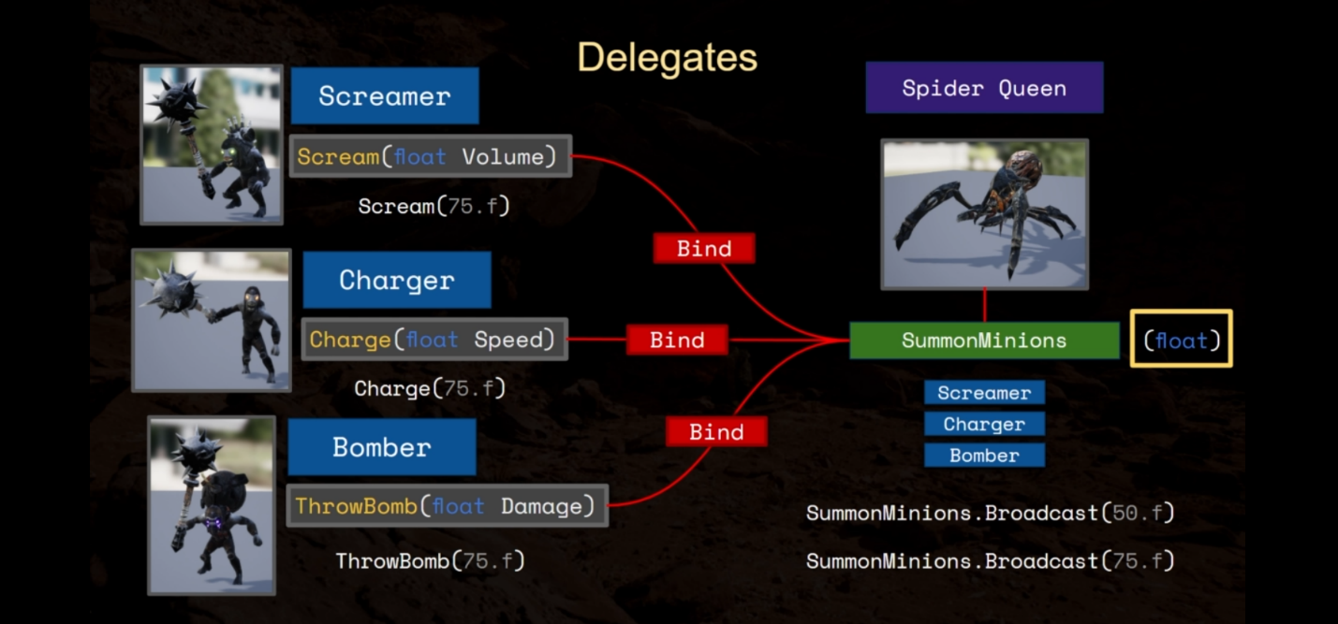

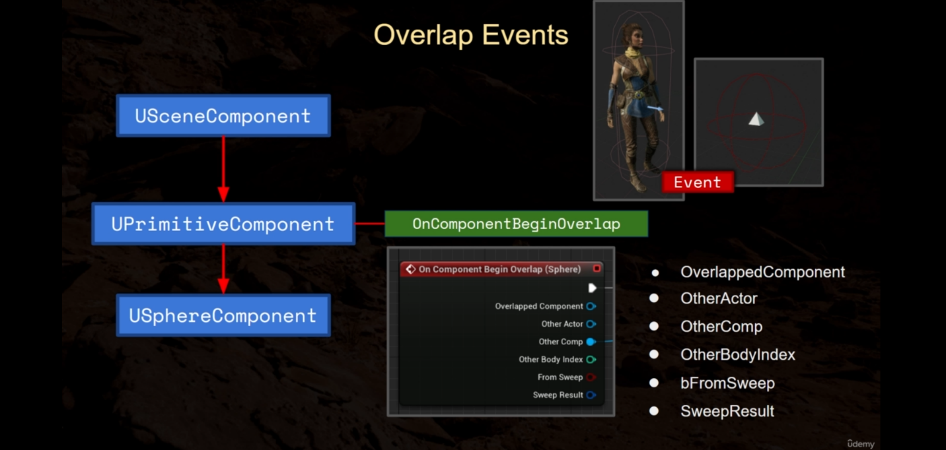

Here before we checked “That Sphere is set to overlap (World Dynamic) object type” and Character Capsule has the collision type “Pawn” ; Now as long as the capsule is not set to ignore Sphere Object types ( World Dynamic ) , so overlap events are possible. Also since it is inherited from UPrimitiveComponent so USphereComponent can be bind to delegates.

Here above Delegate ( OnComponentBeginOverlap ) broadcasts the given 6 broadcast values.